

School of Computer Science, UPES, Dehradun.

Lab 15

DevSecOps Lab

B.TECH. - V Semester

**Submitted to:**

Dr. Hitesh Kumar Sharma

**Submitted by:**

Name: Ishika Mehrotra

Batch: Devops B1

Sap Id: 500124411

Roll No.: R2142230281

**Lab Exercise 6– Terraform Variables**

**Objective:**

Learn how to define and use variables in Terraform configuration.

**Prerequisites:**

• Install Terraform on your machine.

**Steps:**

1. **Create a Terraform Directory:** 
   * Create a new directory for your Terraform project.

**mkdir terraform-variables cd terraform-variables**

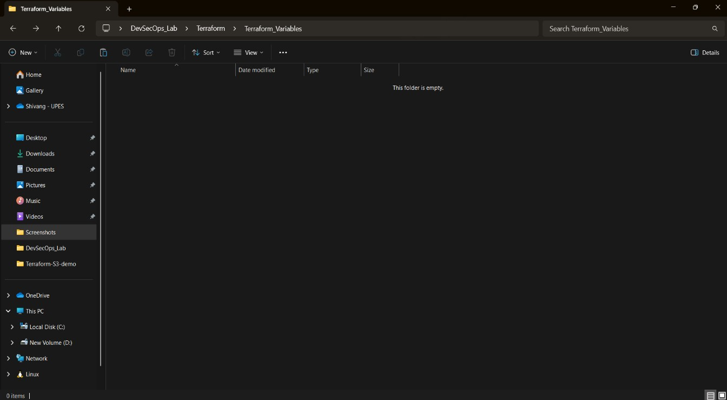

1. **Create a Terraform Configuration File:** 
   * Create a file named main.tf within your project directory. **# main.tf**

resource "aws_instance" "myinstance-1" { ami = var.myami

instance_type = var.my_instance_type count = var.mycount tags = {

Name= "My Instance"

}

}

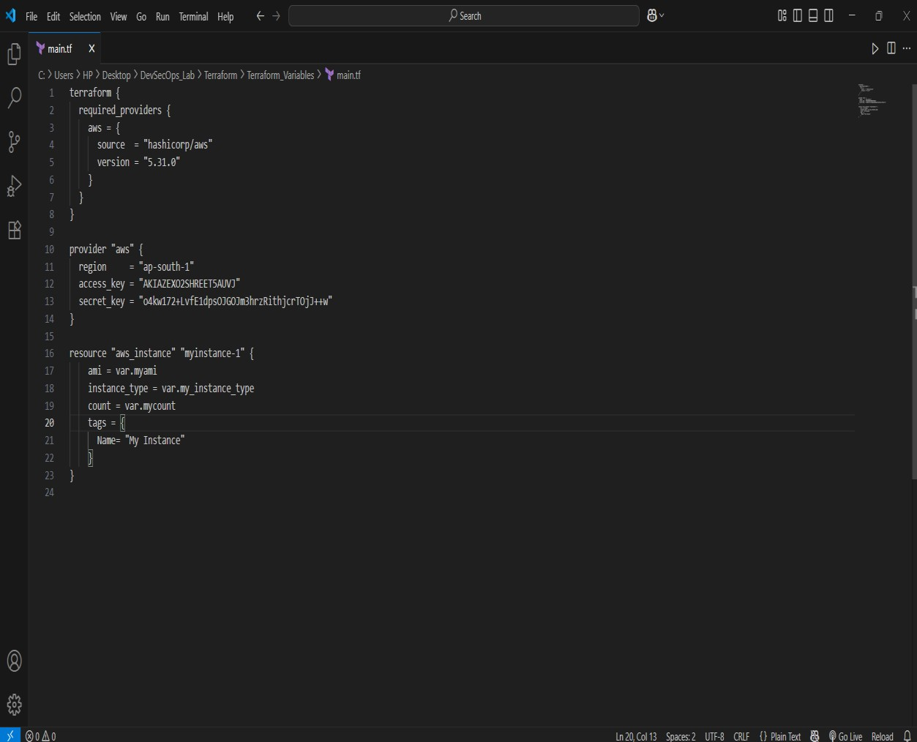

1. **Define Variables:** 
   * Open a new file named variables.tf. Define variables for region, ami, and instance_type.

|  |
| --- |
| variable "myami" { type = string  default = "ami-08718895af4dfa033"  }  variable "mycount" { type = number default = 5  }  variable "my_instance_type" { type = string default = "t2.micro"  } |

**# variables.tf**

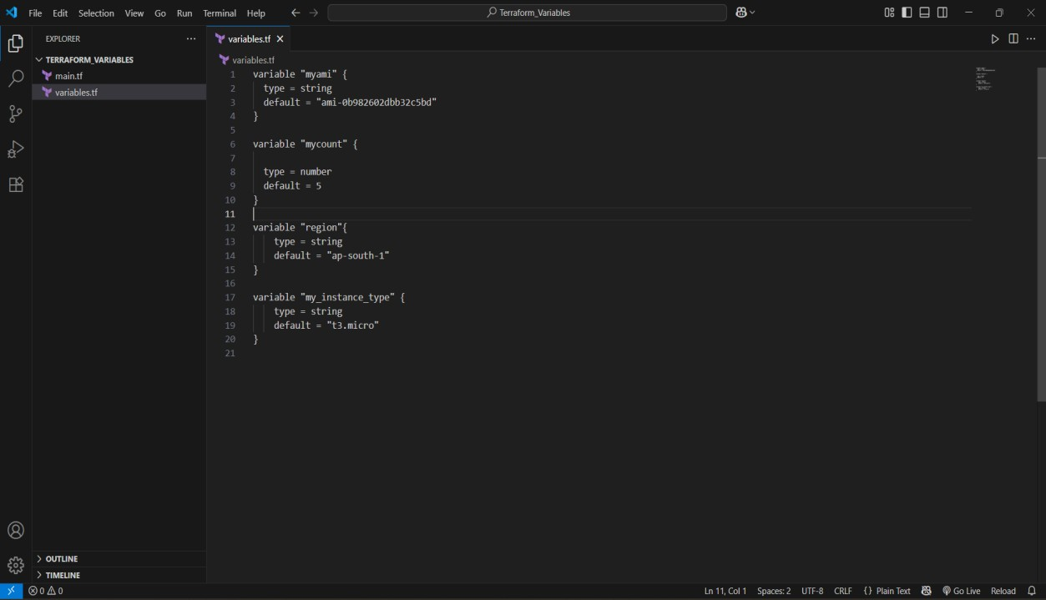

1. **Initialize and Apply:** 
   * Run the following Terraform commands to initialize and apply the configuration.

**terraform init terraform plan terraform apply -auto-approve**

Observe how the region changes based on the variable override.

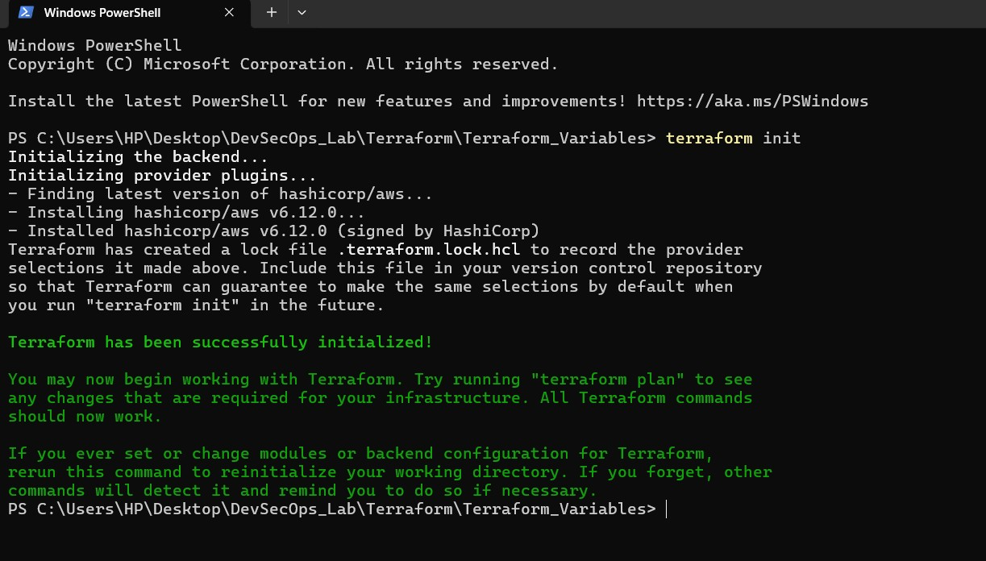

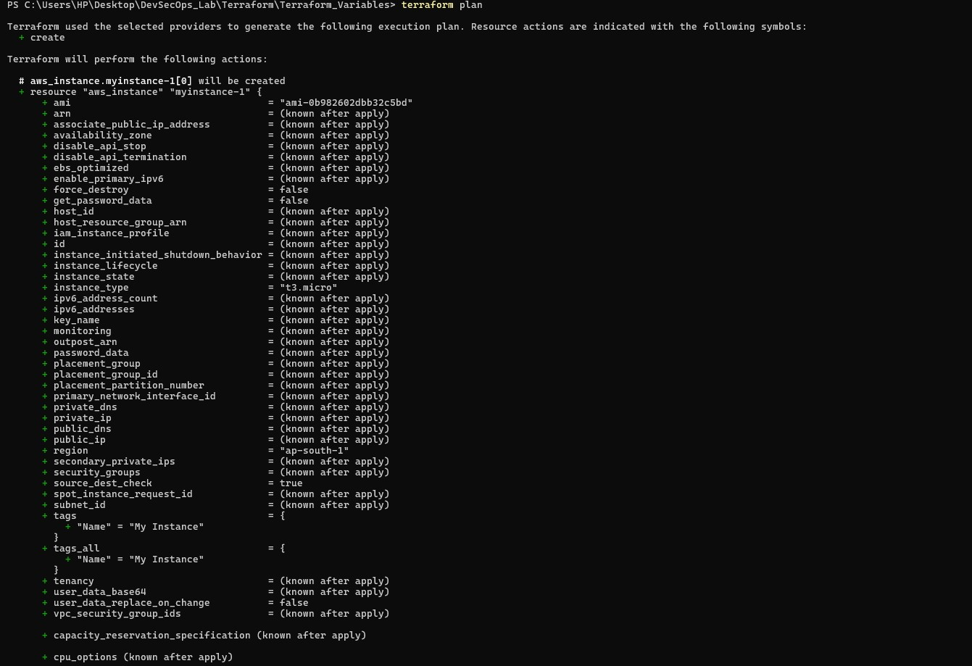

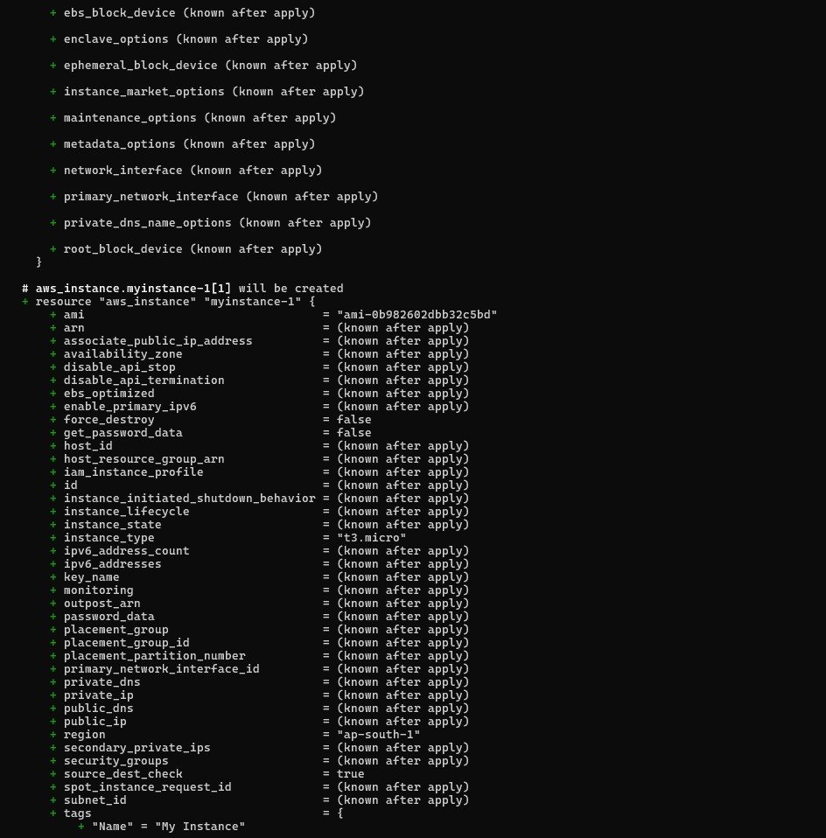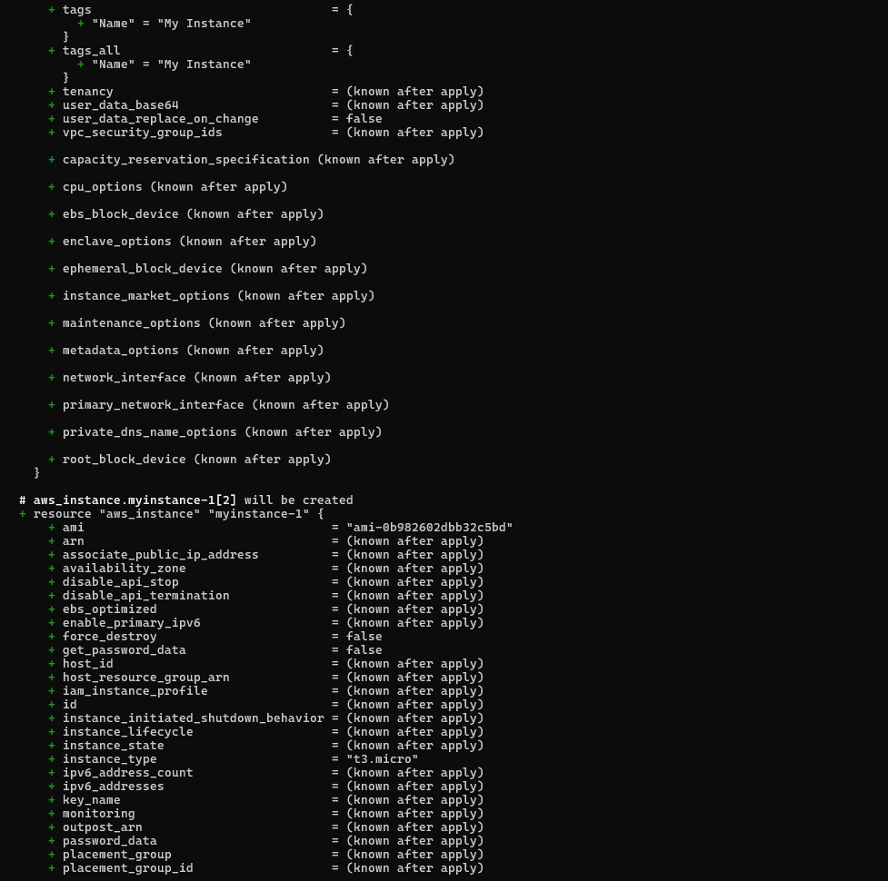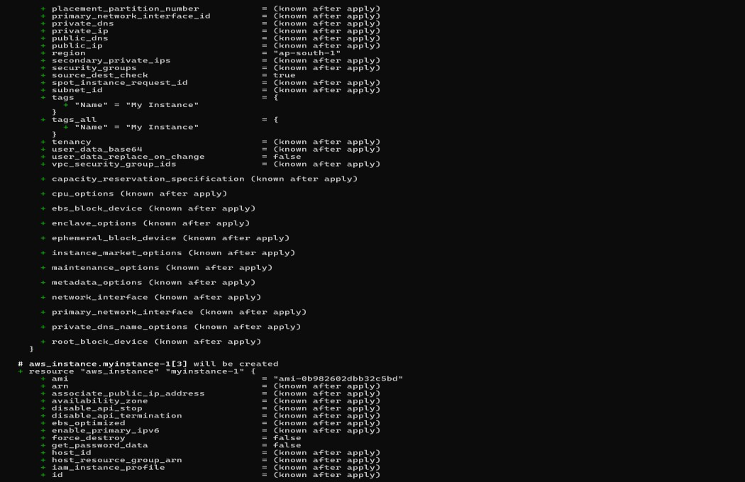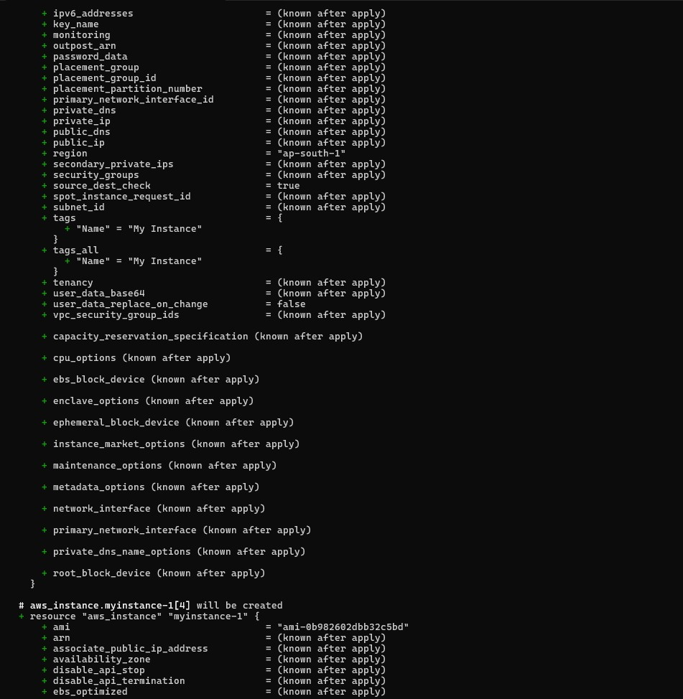

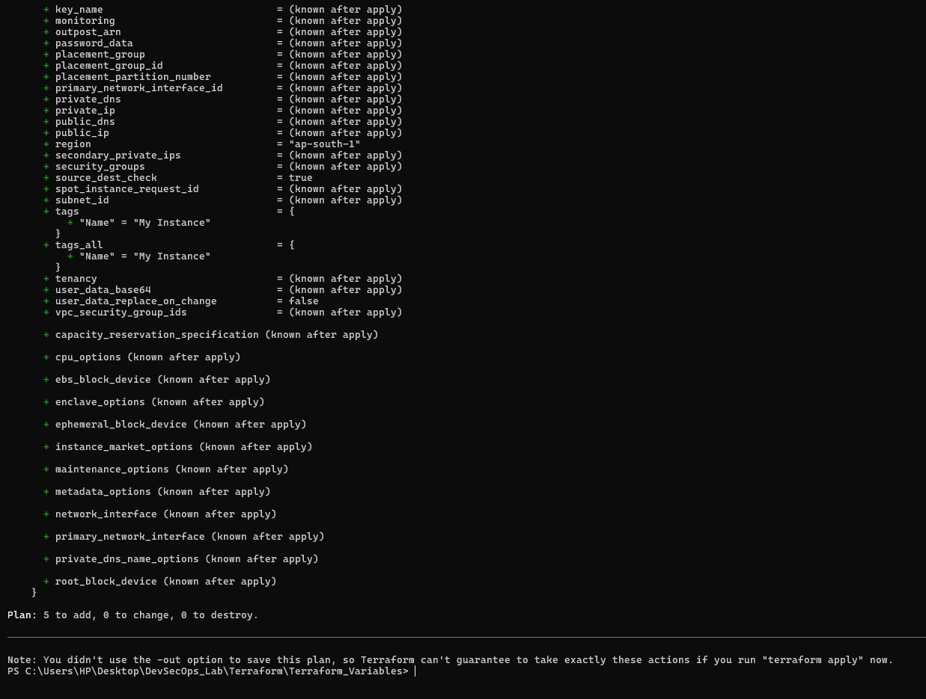

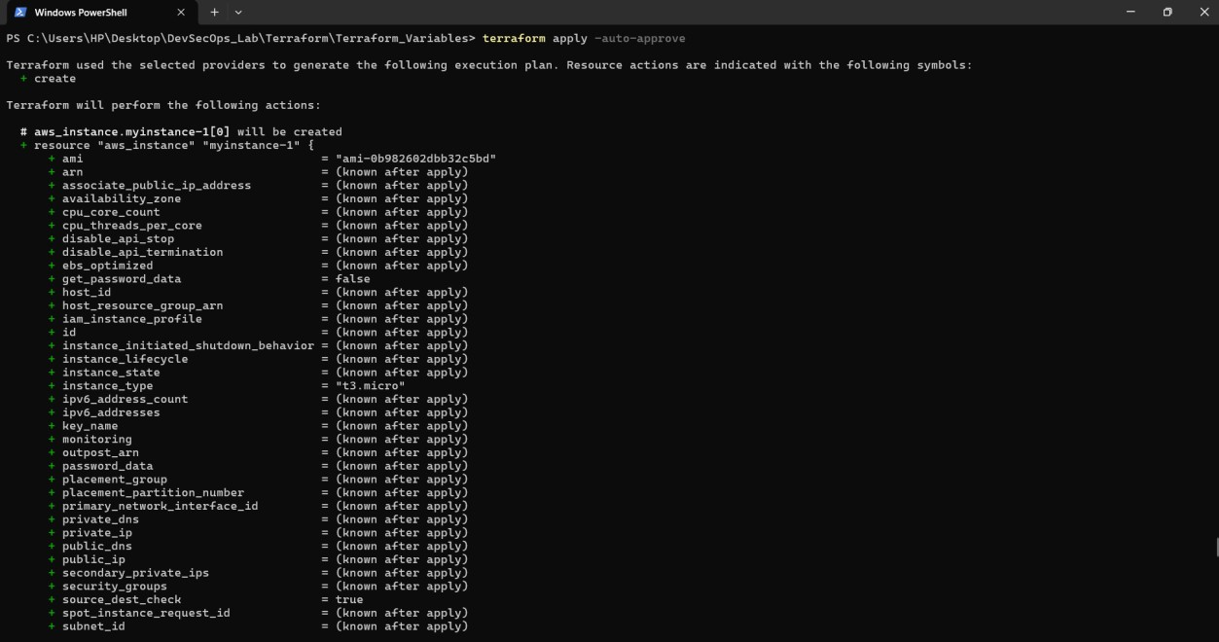

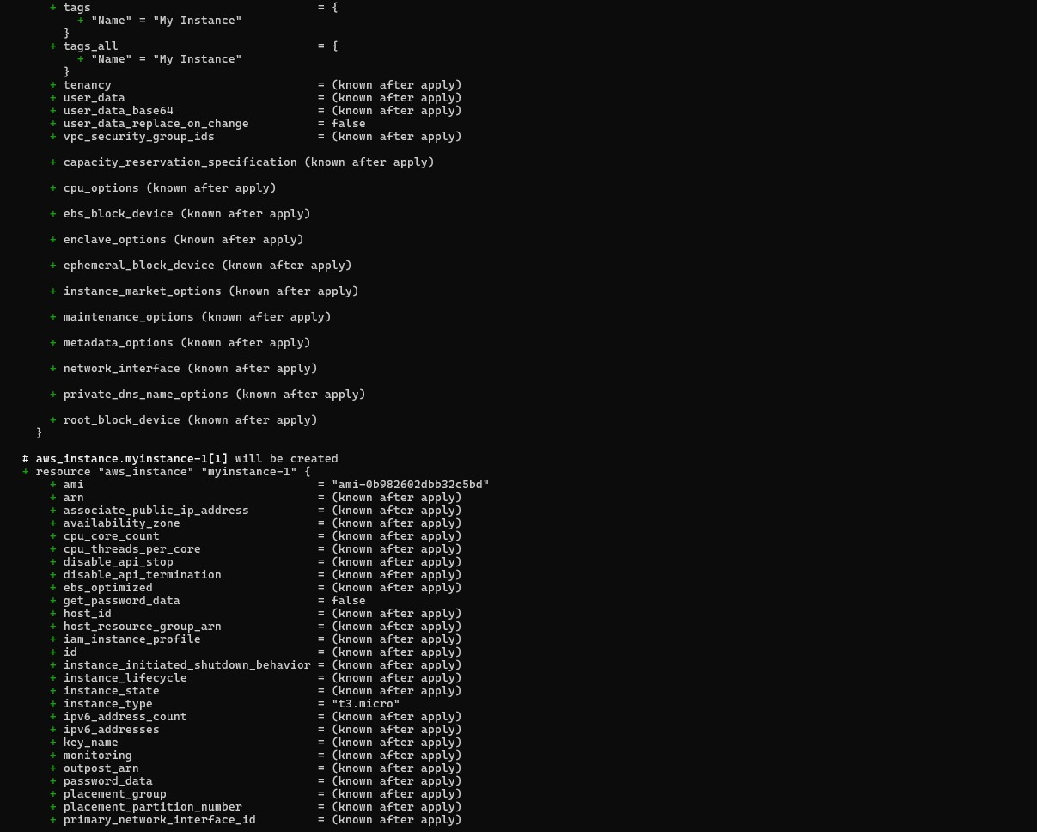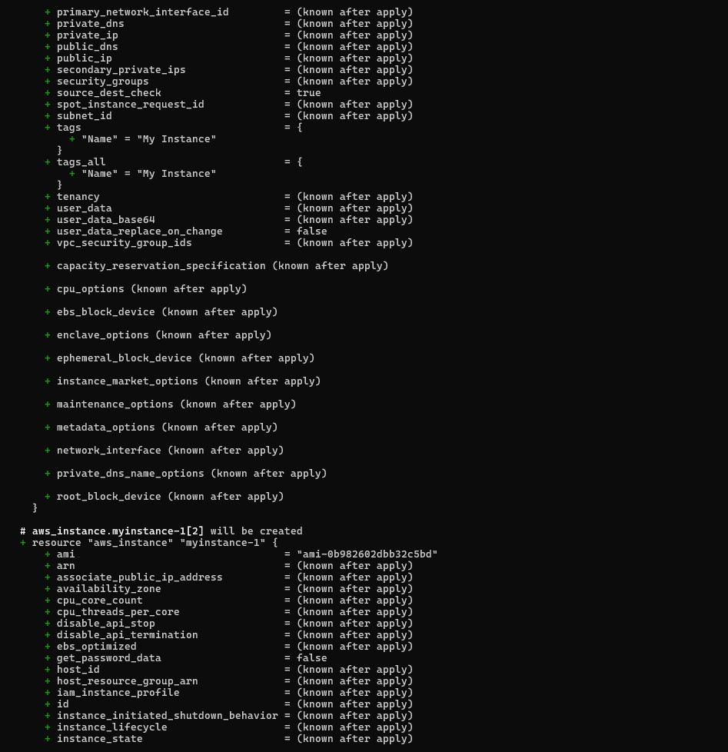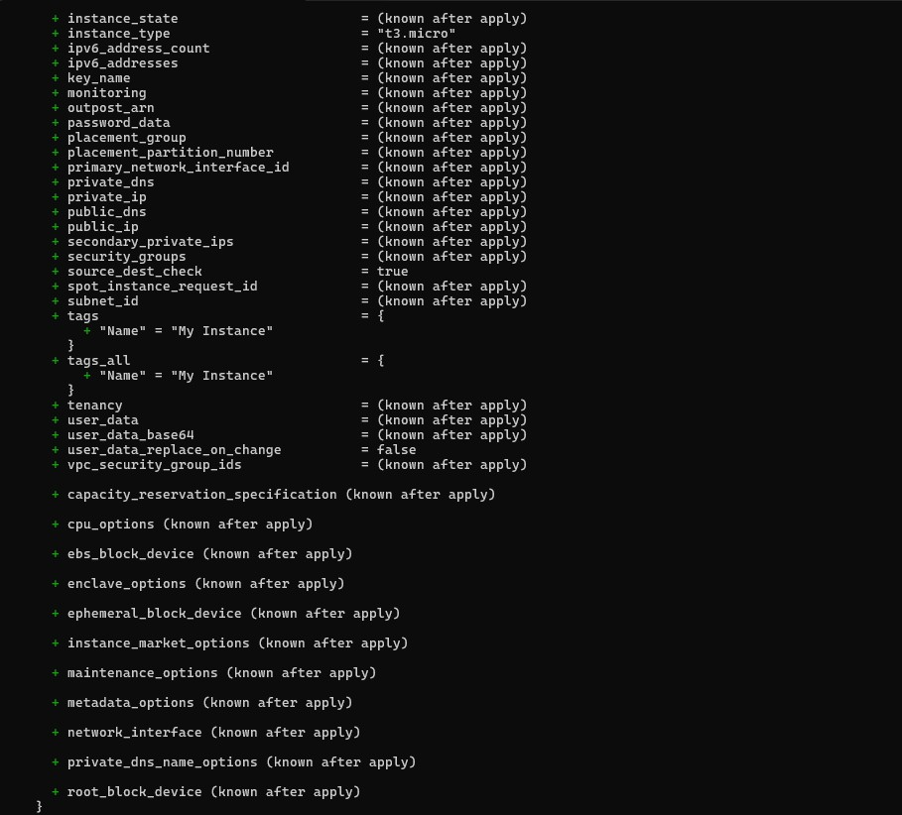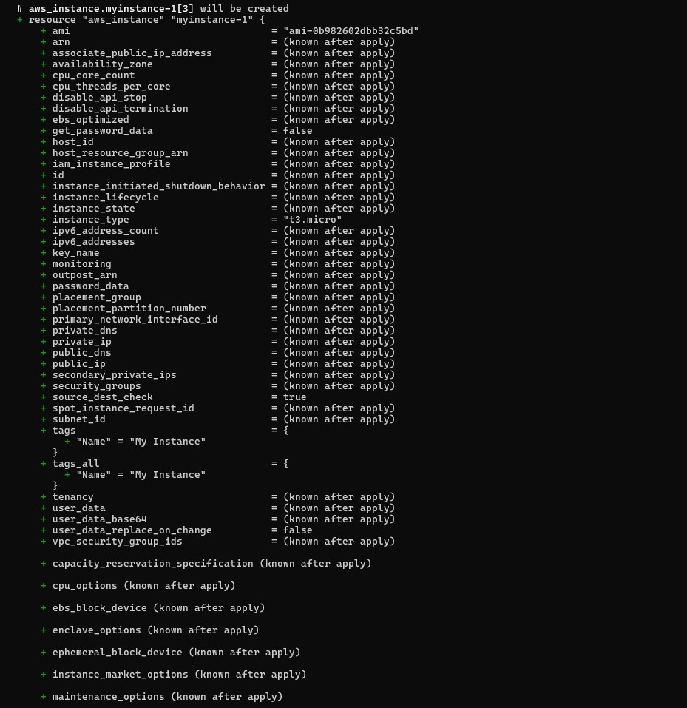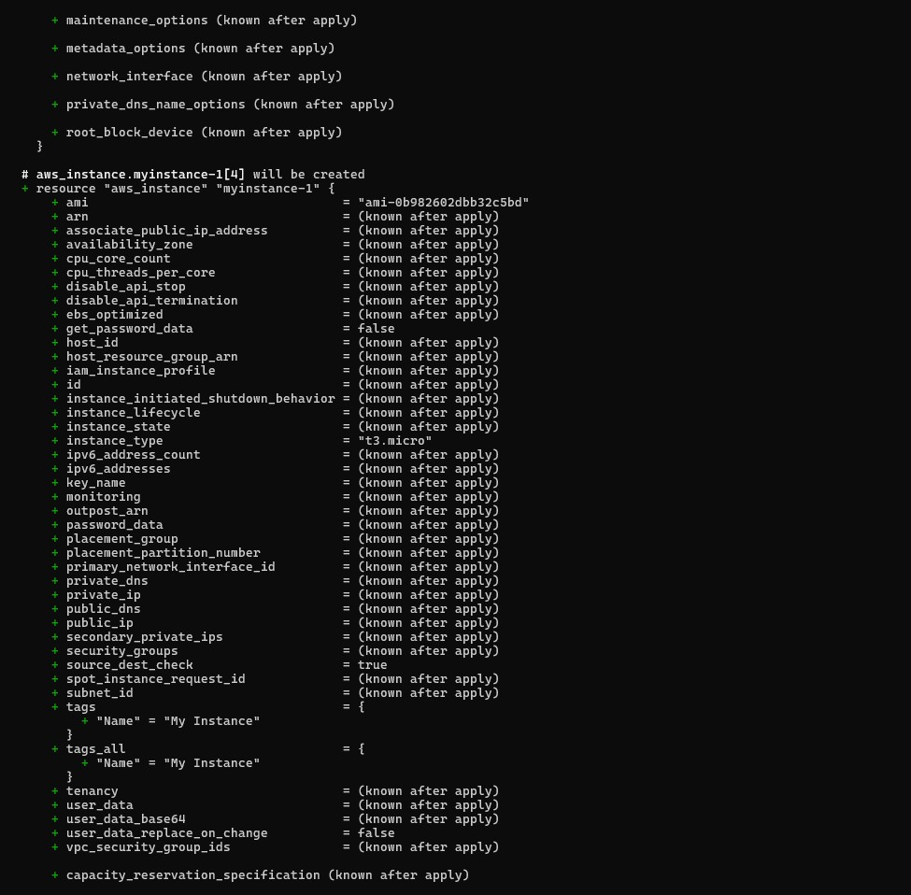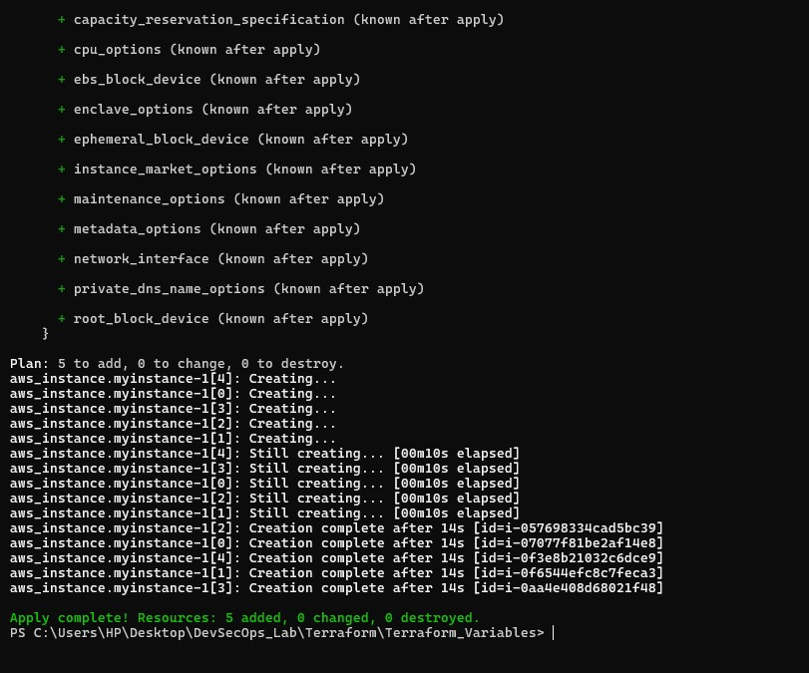

1. **Clean Up:**

After testing, you can clean up resources.

**terraform destroy**

Confirm the destruction by typing yes.

